Build or Decline
The conversations we are already having about current and future policies involve actively building infrastructure as platforms for opportunity and growth
MAY 12, 2025



17
2
Com
It was 2012, and I had emigrated. There weren’t just a few of us, but many: the Spanish migration trend reversed due to the bursting of a credit bubble centered on real estate. What stuck in the Spanish collective imagination was that the real estate sector had wiped out the expectations of a generation and a half. Added to this was an economic stimulus package, dubbed Plan E, which focused on infrastructure projects of dubious added value. The poor decisions made immediately following that crisis led to another European debt crisis, in which we played a leading role alongside our neighboring countries.
All of this served as an understandable counterbalance to a decade of growth based on bricks and mortar. In 2012, journalists from across Europe visited us to tour white elephants. When I was in Valencia, the epicenter of the crisis, I took a few of them here:

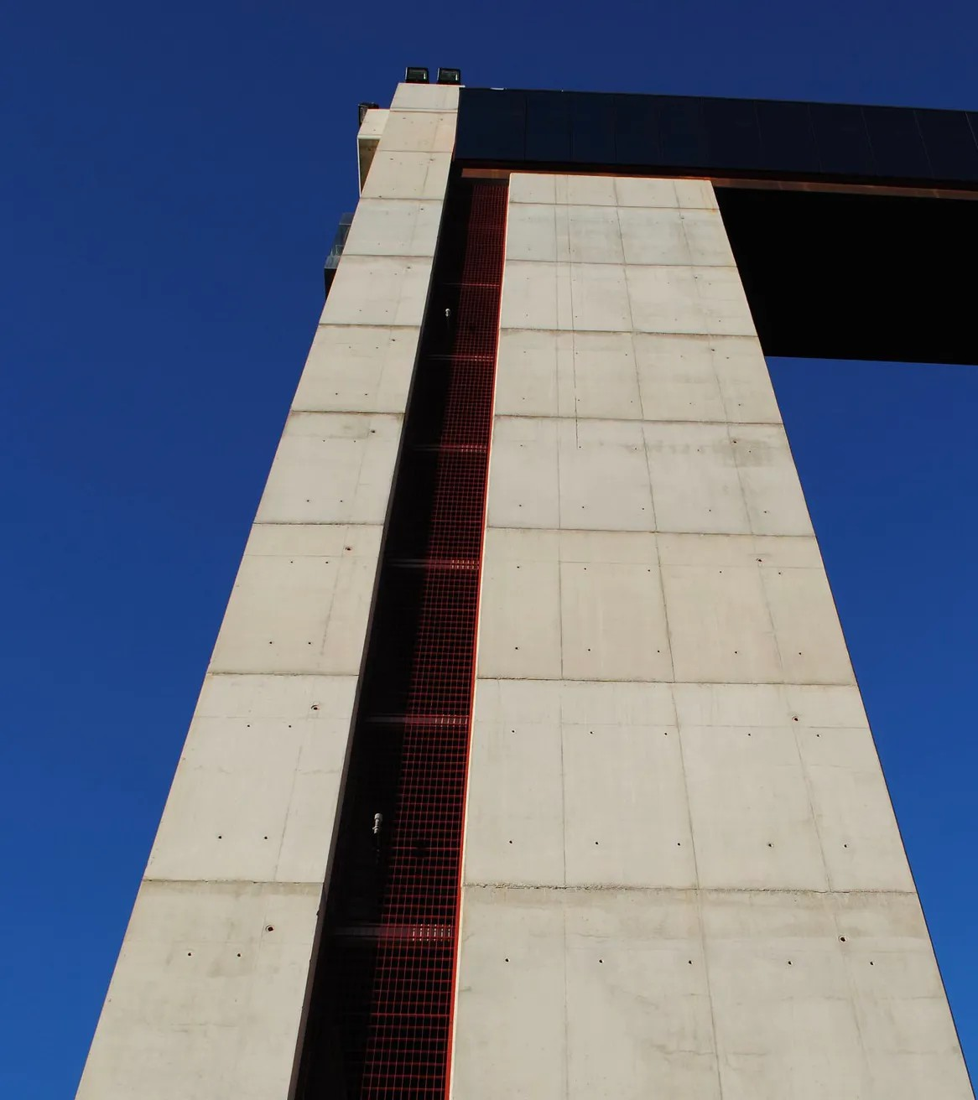

cc - Marina Escandell.

This is a reinforced concrete observation tower in the middle of a roundabout at the entrance to the city.
Considered one of the most expensive roundabouts in Spain [24 million d

[The very idea of “more expensive roundabouts” is striking in itself.] It was inaugurated in 2009 by then-Prime Minister José Luis Zapatero and then-Mayor of Valencia Rita Barberá.
A 45-meter-high concrete tower was erected to serve as a viewpoint overlooking the Valencian countryside and the sea. The structure was accompanied by an underpass [with some puzzling “non-fountains”] and a 7,000-square-meter roundabout that would need nothing more than its presence to fulfill its functions as a roundabout and tunnel—something that would have cost a fraction of the investment.
Within a few weeks, the elevator that took you up to the top floor—a small glass-enclosed area with views that turn into an oven in the summer—broke down. As if that weren’t enough, the views aren’t exactly spectacular [I can confirm that]. So, three months after it opened, the observation deck closed for good.
Raquel Andrés · La Vanguardia [with my notes]

It’s inevitable that when people think about infrastructure in Spain from the outside, things like this come to mind. That’s just how it is. But we’re going to have to think beyond that. And, in fact, the lessons learned over the past decade can be useful to us as we enter this new era. I believe that infrastructure—or rather, the physical infrastructure—is going to take on a new central role in decisions that are crucial for our present and future. A recent overview:
- A major blackout in which it appears that both the grid operator’s immediate response to the incident and the fact that the grid itself lacks sufficient mechanisms to manage an energy system increasingly reliant on renewables played a role (1, 2, 3).

- (And, in any case, climate change is not something we can simply ignore—with emergencies and disasters, such as Storm Dana, that require a better-prepared society.)
- A defense budget that already sets 2% as the floor and looks to 2% as the ceiling
- A slow but inexorable shift in the housing debate toward the need to increase supply
- The question of what we are going to do with our supply chains and the systems that support them in a more uncertain and fragmented commercial environment
- (And to that we add the successive disruptions to supplies and other issues dating back to shortly before Russia’s invasion of Ukraine
If you add it all up, it turns out that, after years of debate marked by largely symbolic or cultural issues (some with strong content and impact on minority rights, others perhaps not so much), the material is demanding space.
To address this, I propose starting with an apparent paradox that does not
How do we align infrastructure investment with an economy where the source of growth is increasingly the value of ideas, knowledge, and human capital? What I suggest is precisely to use this as a yardstick. As a starting point, we could say that the most worthwhile investments would be those that meet any of the following conditions:
- They enhance knowledge and human capital.
E.g., early childhood education centers (ages 0–3); specialized applied research centers; more integrated vocational training systems.

- They facilitate equitable access to education; that is, they promote equal opportunities to contribute to and benefit from it.
E.g., affordable housing where people want to come to study or to
- They are based precisely on these contributions: they increase productivity or improve public goods through innovation driven by ideas or knowledge.
Examples: early warning systems or infrastructure adaptations to withstand climate emergencies; next-generation vaccines; AI for public services.
- They protect us so that we can continue to contribute.
E.g.: joint operational capabilities in defense with EU partners—we are clear about NATO’s future; protection of connectivity infrastructure.
To sum it up, it would be a perspective of infrastructure as platforms, borrowing the concept from Fernando Caballero, who applied it to cities in his wonderful Madrid DF. And to expand it both in scope and concept. Platforms upon which to do more. One cannot build on a nondescript viewpoint, nor on a housing development built in the middle of nowhere. But one can do a lot by supporting housing built where people want to live (and cannot); in new early childhood education centers; by better equipping those schools and universities that already exist and are subject to growing demands; by creating a more robust energy system that is less dependent on sources that should not deserve our trust; with fast, efficient, and fail-safe transportation networks; and by equipping ourselves with the means to defend our interests.
It is by no means clear, incidentally, that the injection of €80 billion that re

Spain’s use of funds to combat the crisis caused by the pandemic is entirely consistent with this approach. It would be interesting and instructive to systematically review it from this perspective: with 95% of the funds already committed, refocusing is more difficult. We can only analyze it in hindsight, but that alone would be helpful.
Circumstantial evidence that the implementation of these NextGen Europe funds is not sufficient to create platforms for growth is the very existence of Mario Draghi’s report on competitiveness in Europe. One way to interpret it is as a call to achieve sufficient economic scale to harness the full potential of our continent, our Union. A central part of the entire conversation it has sparked involves “letting things happen”—unleashing the potential for private investment and action. But there is another, equally important aspect that has to do with taking action—whether at the EU, national, or local level—so that others can do more.
Here lies an opportunity for progressive political positions to find their place. It is, essentially, the path that Ezra Klein and Derek Thompson have taken in their book *Abundance*. It is the one that Matt Yglesias, Smith, and others have been advocating for some time in the U.S. To capitalize on this, progressive discourse must shed five barriers that currently hold it back:
- Avoid “zero-sum” thinking—the idea that the first (and in some cases, seemingly the only) thing that allows progress is the scarcity of what we have.
*Even worse, though fortunately less common, is “negative-sum” thinking. Degrowth, in other words. It is a politically unpalatable idea to most people once they see its real-world consequences;

socially insensitive to those who still do not have enough to live a reasonably comfortable life; and technologically denialist about what the future may hold for us.
- An excessive reliance on regulations as a means to achieve [the desired outcome]. The paradigmatic example for me, at least in Spain, is the obsession with regulating housing prices in major cities (with likely counterproductive results) rather than considering whether we should be investing in housing at all.
- Present and future debts incurred through areas of the welfare state that have become obsolete yet still absorb resources that could be allocated elsewhere. In a context of budgetary constraints (which is, let’s not forget, any realistic context): do I prefer to divert fiscal resources to the pension system or to early childhood education (0-3)? But of course: the votes are more in the former than the latter, as are the financial commitments already made.
- The focus of discourse on issues that are not only detached from material concerns but also fail to yield political gains. Aspects of the “culture wars” that have less to do with protecting rights and advancing equality and more to do with symbolic or superficial matters could benefit from more nuanced positions. And others, more fundamental issues, could be achieved just as effectively without being so prominent: when in power, a party gets things done. It doesn’t have to talk about everything with the same intensity.
- We must not ignore that the electorate attributes a certain value to the ideology of security. Ganesh reproached Klein and Thompson in his FT column for claiming that “abundance doesn’t win elections,” but perhaps the idea of order does. I would simply qualify that as protection. Order is not an end in itself: the end is to feel safe and protected.












And if we don’t do it? Decline, I fear. The thing about decline is that it doesn’t have to come in the form of a shock. Unlike the bursting of the bubble, which made it crystal clear what we shouldn’t do again—and to remember it. But doing nothing produces no result by definition. So it’s harder to compare it to the world that could have been. But it’s an effort we must make anyway—building a watchtower at a roundabout and sharing the scarcity—there’s an alternative path we’re taking too long to explore more decisively

17 Likes ∙ 2 Restacks

Discussion on this post

Comments Restacks

Write a comment...

© 2026 Jorge Galindo · Privacy ∙ Terms ∙ Data Collection Notice · Substack is the home of great culture

